Metropolitan State University

ICS 140 Computational Thinking with Programming

Class Exercise 4

**Lecture Section**

1. What control structure are we using when we perform actions only if a specified condition exists?

Decision structure

1. In a flow chart diagram, what shape represents a true/false condition that must be tested?

Rotated square

1. What keyword is used at the beginning of a statement that checks a condition to determine whether a block of code should be executed or not?

“if”

1. What type of expression can result in true or false and is used for a conditional test.

Boolean expression

1. What is the difference between the (=) operator and the (==) operator?

One is an assignment operator and the other is a equality operator

1. What type of operator checks if one value is NOT equal to another?

!=

1. What keyword can be used in a conditional statement to specify a block of code that should be run only if the previous condition was not met?

else

1. When comparing strings, how does python determine which string is greater than another?

Using ASCII code value and assesses left to right

1. What keyword is used to check a second potential condition following an if statement?

elif

1. How are statements lined up to indicate they are subject to an if statement?

Using the Tab or space with proper indenting

**Writing iffy statements**

Write the python code for the following situations. I have highlighted variable names in bold.

1. Print ‘red’ if the variable **rgb** is 10.

If rgb == 10:

Print(‘red’)

1. Store the value of **x** into **y** if the value of **z** is less than 10.

If z < 10:

Y = x

1. Set the **price** to 0, if the value of variable **discount** is more than the variable **sales_price**.

If discount > sales_price:

Price = 0

1. If the **number_of_dependents** is more than 0, set **withholding** to 100; otherwise, set **withholding** to 1000.

If number_of_dependents > 0:

Withholding = 100

Else:

Withholding 1000

1. If the value of **tax_paid** is more than **computed_tax**, set **refund** to **tax_paid** minus **computed_tax**. Otherwise, set **tax_owed** to **computed_tax** minus **tax_paid**.

if tax_paid > computed_tax:

refund = tax_paid – computed_tax

else:

tax_owed = computed_tax – tax_paid

1. If **number_of_sides** is 3, print ‘It is a triangle’. Otherwise, print ‘It is not a triangle’

If number_of_sides == 3:

Print(“it is a triangle”)

Else:

Print(“It is not a triangle”)

**Programming Exercise**

For the following exercise, you can use the python files included in this assignment to create a simple program that will prompt the user to enter a number and then tell them if the number is odd or even.

It should look like so:



Or

*HINT: We can use the modulus operator to divide a value by 2 and see if it has a remainder of 1 or 0. If the remainder of a value divided by 2 is 1, then the number is odd, if the remainder is 0, then it is even.*

Copy the python code in the section below. Copy and paste screenshots running the program to show it works properly for both even and odd numbers.

**Python Code**

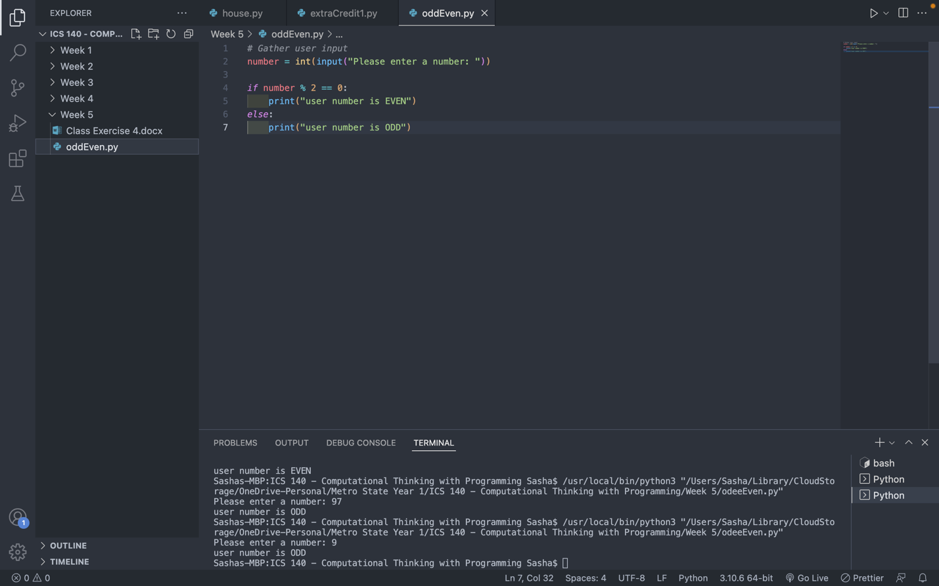

**Test Results**

Test results in above picture